LAB 9

DARSHAN KALPESHBHAI PRAJAPATI

ID : 112908215

1. Write a query to return *name* and *price* of each product in the *inventory* database.

|  |
| --- |
| db.products.find({}, { name: 1, price: 1, _id: 0 }) |

1. Write a query to return *name* and *price* for products of type “Health Care” in the *inventory* database.

|  |
| --- |
| db.products.find({ type: "Health Care" },{ name: 1, price: 1, _id: 0 } ) |

1. Write a query to return *name* and *price* for products with price between $12 and $20 (Values *12* and *20* are included).

|  |
| --- |
| db.products.find( { price: { $gte: 12, $lte: 20 } }, { name: 1, price: 1, _id: 0 }) |

1. Write a query to return *id*, *name*, *price*, and *type* for products that are not of type “Health Care”.

|  |
| --- |
| db.products.find( { type: { $ne: "Health Care" } }, { name: 1, price: 1, type: 1 }) |

1. Write a query to return *id*, *name*, *price*, and type for products with type “Health Care” or “Consumer Services.”

|  |
| --- |
| db.products.find( { type: { $in: ["Health Care", "Consumer Services"] } }, { name: 1, price: 1, type: 1 }) |

1. Write a query to return *id*, *name*, *price*, and *type* for products that do have the *type* key.

|  |
| --- |
| db.products.find( { type: { $exists: true } }, { name: 1, price: 1, type: 1 }) |

1. Write a query to return *id*, *name*, *price*, and *type* for products that their type is both Health Care and Consumer Services.

|  |
| --- |
| db.products.find( { type: { $all: ["Health Care", "Consumer Services"] } }, { name: 1, price: 1, type: 1 }) |

ANS 1: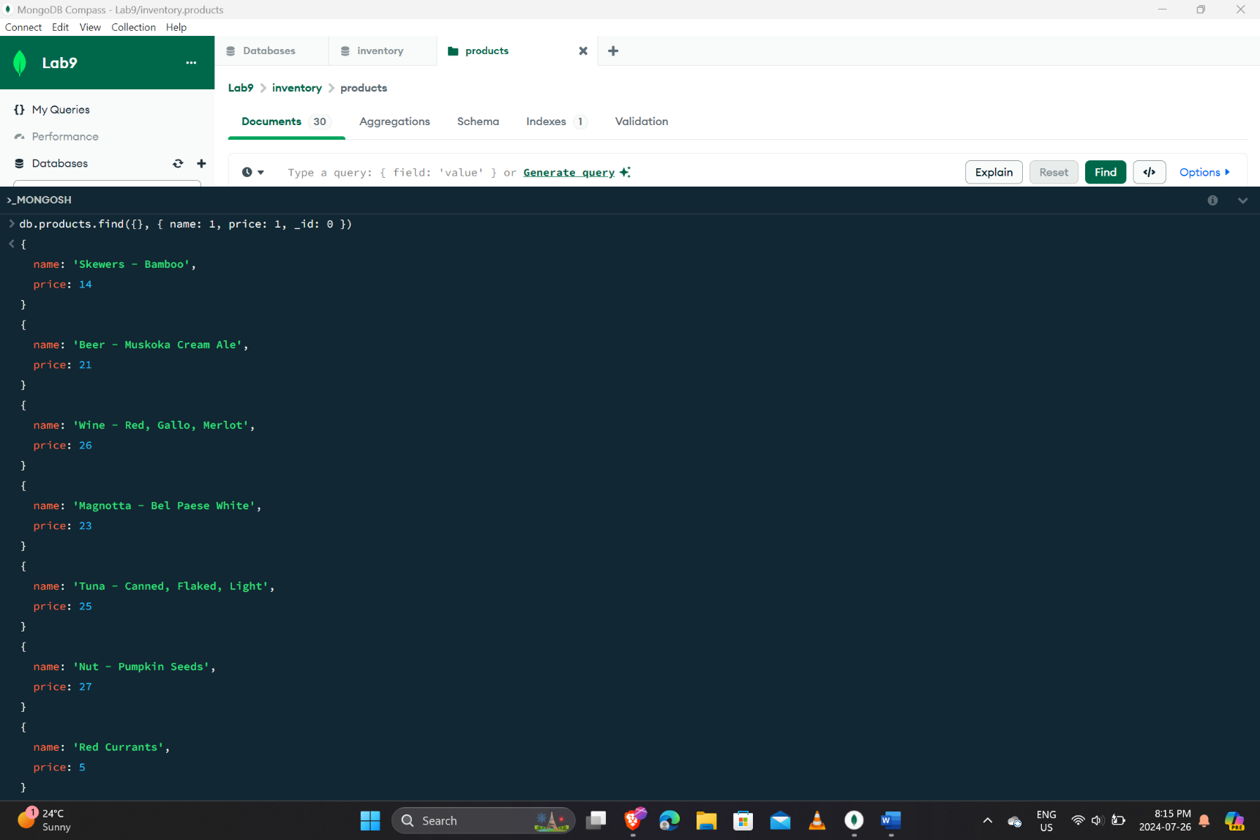

ANS 2: 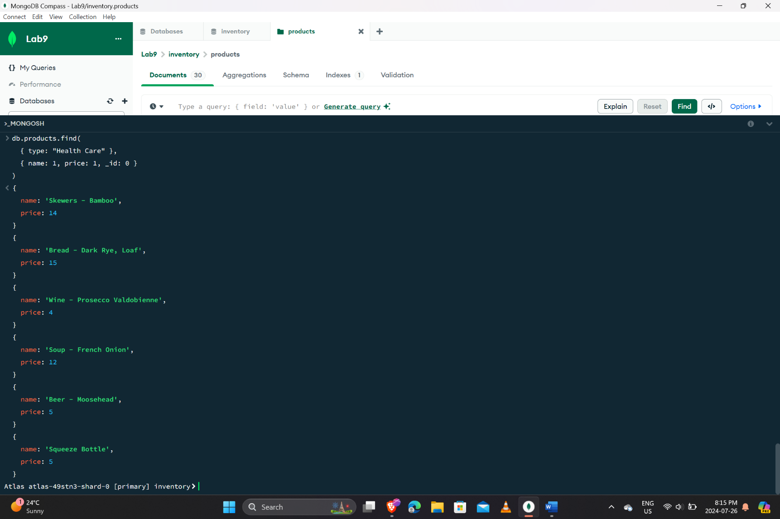

ANS 3: 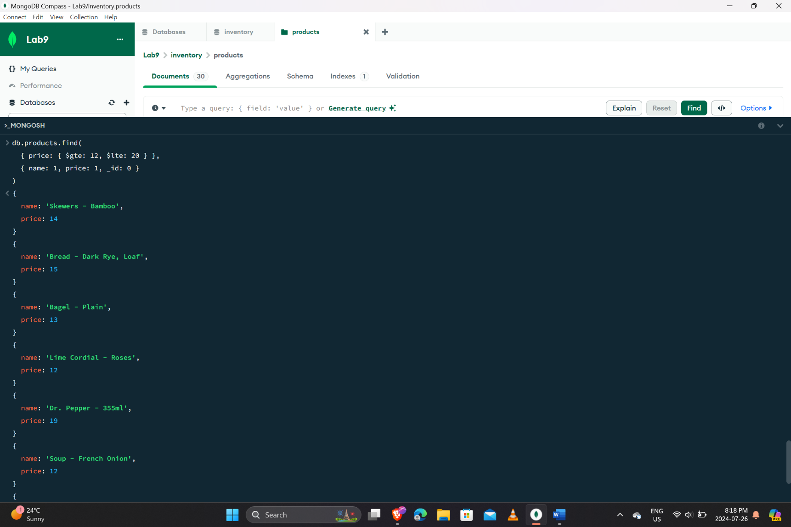

ANS 4: 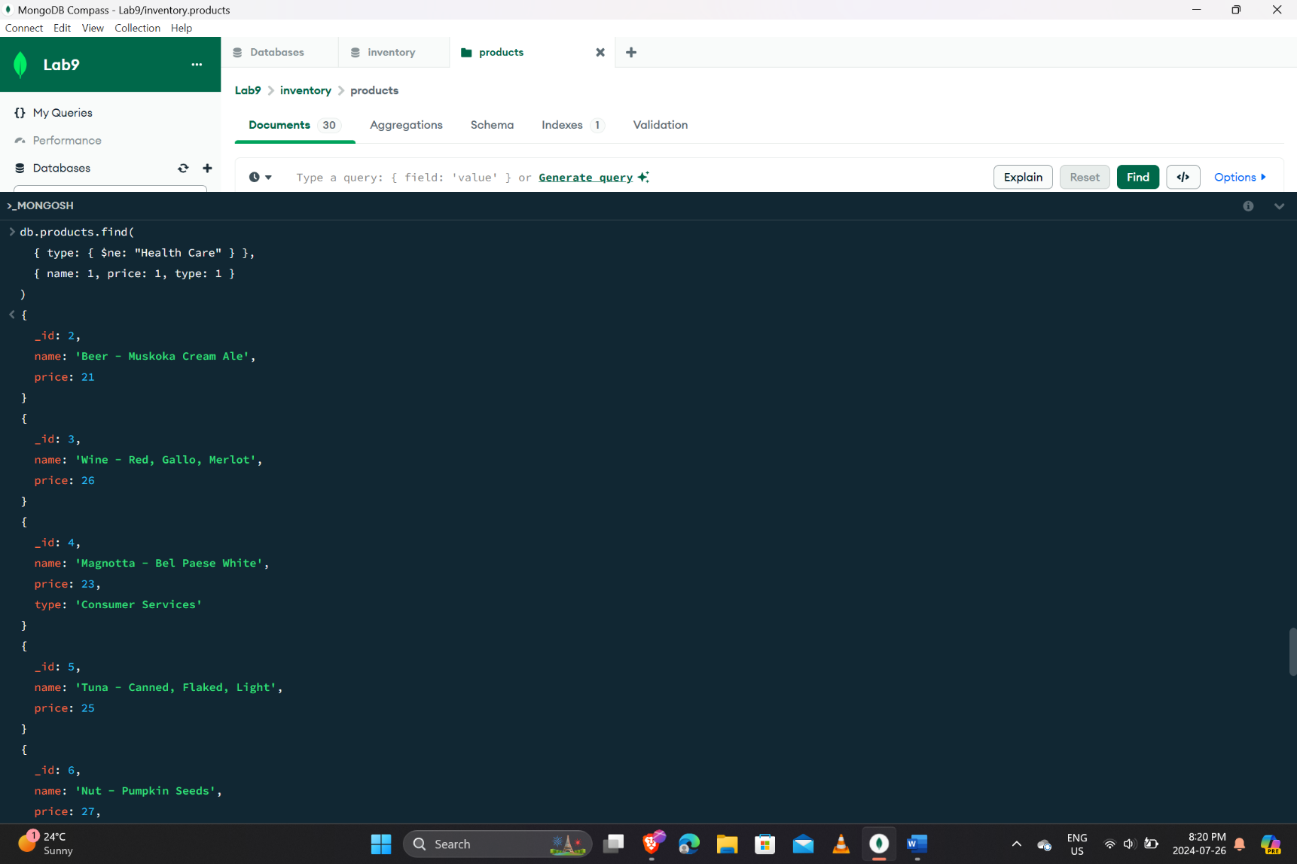

ANS 5: 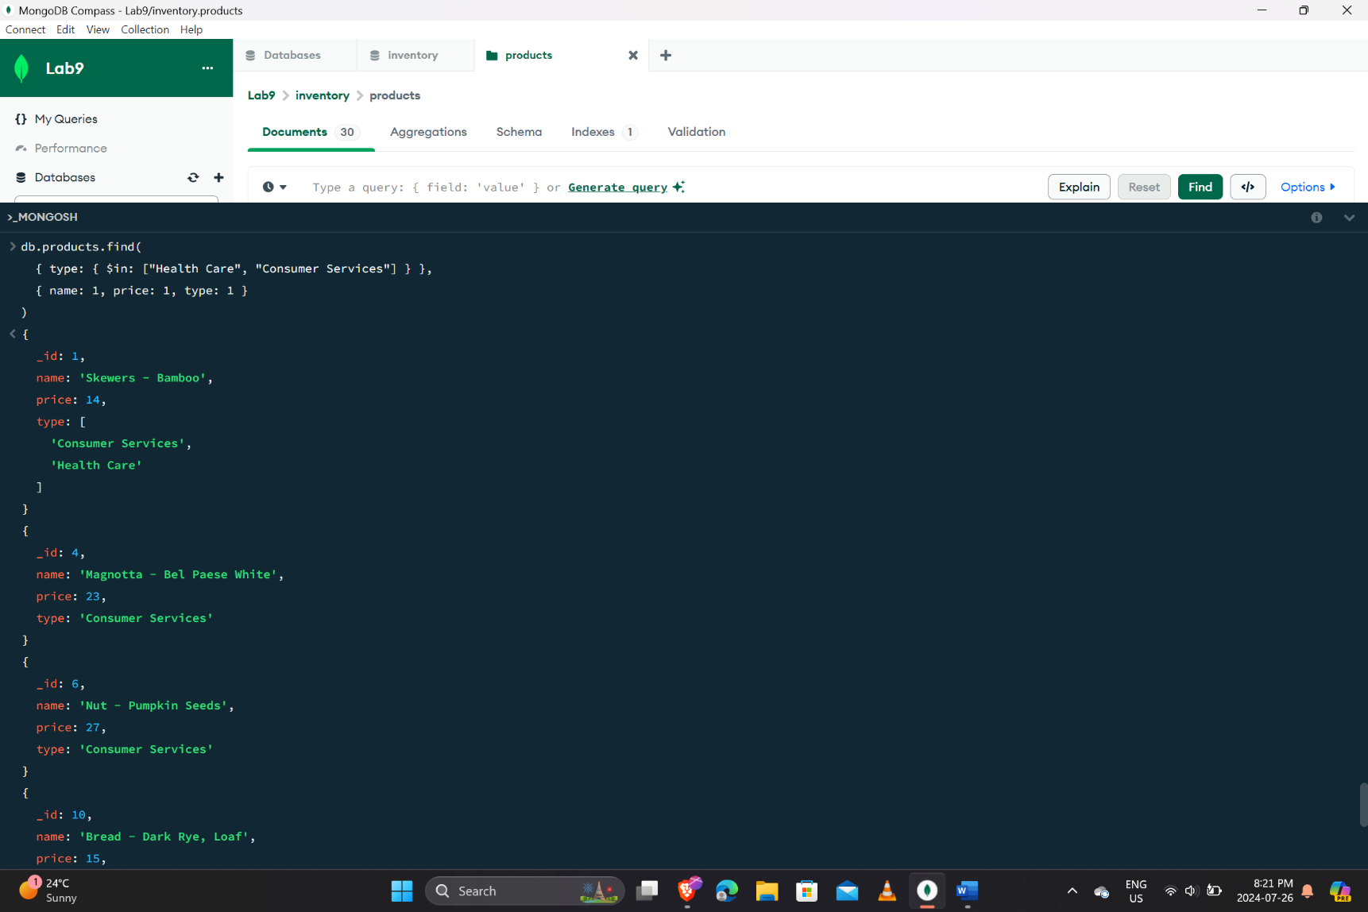

ANS 6: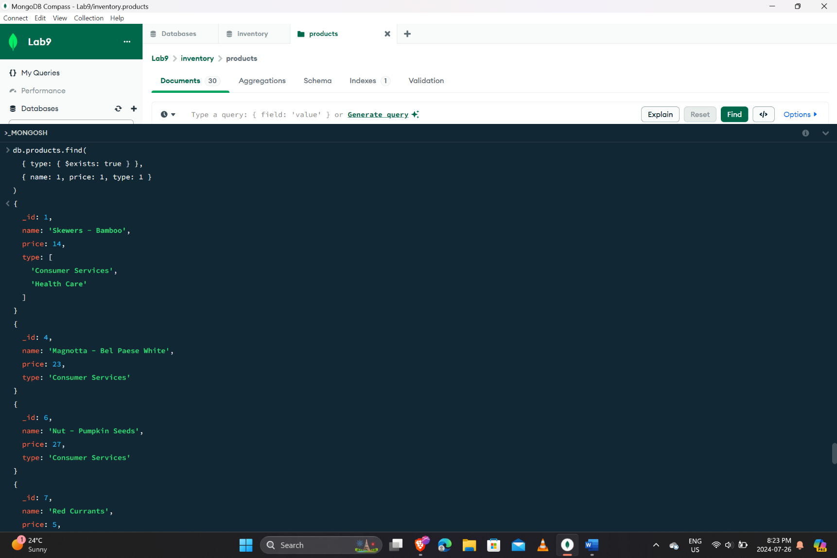

ANS 7: 